**NAME: سيف الدين إبراهيم عوض إبراهيم**

**B.N: 409**

**TOPIC:** **Database** **Systems**

**DATE: 30\5\2020**

**GITHUP LINK:**

**GITHUP PAGE:**

## What is Database?

A **database** is an organized collection of data, so that it can be easily accessed and managed.

You can organize data into tables, rows, columns, and index it to make it easier to find relevant information.

**Database handlers** create a database in such a way that only one set of software program provides access of data to all the users.

The **main purpose** of the database is to operate a large amount of information by storing, retrieving, and managing data.

There are many **dynamic websites** on the World Wide Web nowadays which are handled through databases. For example, a model that checks the availability of rooms in a hotel. It is an example of a dynamic website that uses a database.

There are many **databases available** like MySQL, Sybase, Oracle, MongoDB, Informix, PostgreSQL, SQL Server, etc.

Modern databases are managed by the database management system (DBMS).

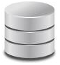**SQL** or Structured Query Language is used to operate on the data stored in a database. SQL depends on relational algebra and tuple relational calculus.

A cylindrical structure is used to display the image of a database.

There are different types of databases. They are:

* Bibliographic
* full-text
* numeric
* images

***Facts about Database:***

* Databases have evolved dramatically since their inception in the early 1960s.
* Some Navigational databases such as the Hierarchical database and the Network database were the original systems used to store and manipulate data. Although these early systems were actually inflexible
* In the early 1980s, [*Relational databases*](https://www.edureka.co/blog/rds-aws-tutorial/) became very popular, which was followed by object-oriented databases later on.
* More recently, *[NoSQL databases](https://www.edureka.co/blog/introduction-to-nosql-database/" \t "_blank)* came up as a response to the growth of the internet and the need for faster speed and processing of unstructured data.
* Today, we have [*cloud databases*](https://www.edureka.co/blog/amazon-dynamodb-tutorial) and self-driving databases that are creating a new ground when it comes to how data is collected, stored, managed, and utilized.
* ***Database Access Language***

It is used to access the data to and from the database. In order to enter new data, updating, or retrieving requires data from databases. You can write a set of appropriate commands in the database access language, submit these to the DBMS, which then processes the data and generates it, displays a set of results into a user-readable form.

Now that you guys have understood how to create a database, let’s move ahead and understand the types.

**APPLICATION BRIEF**:

A database management system is important because it manages data efficiently and allows users to perform multiple tasks with ease. A database management system stores, organizes and manages a large amount of information within a single software application. Use of this system increases efficiency of business operations and reduces overall costs

**SCREAN SHOTS:**

**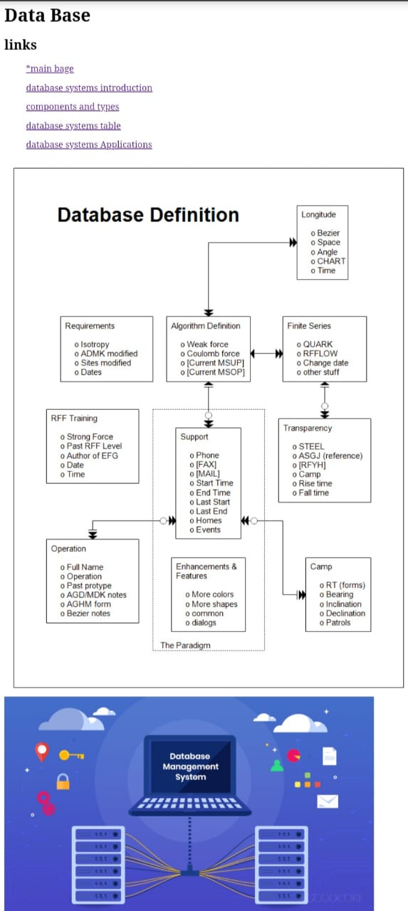**

**Site page 1**

**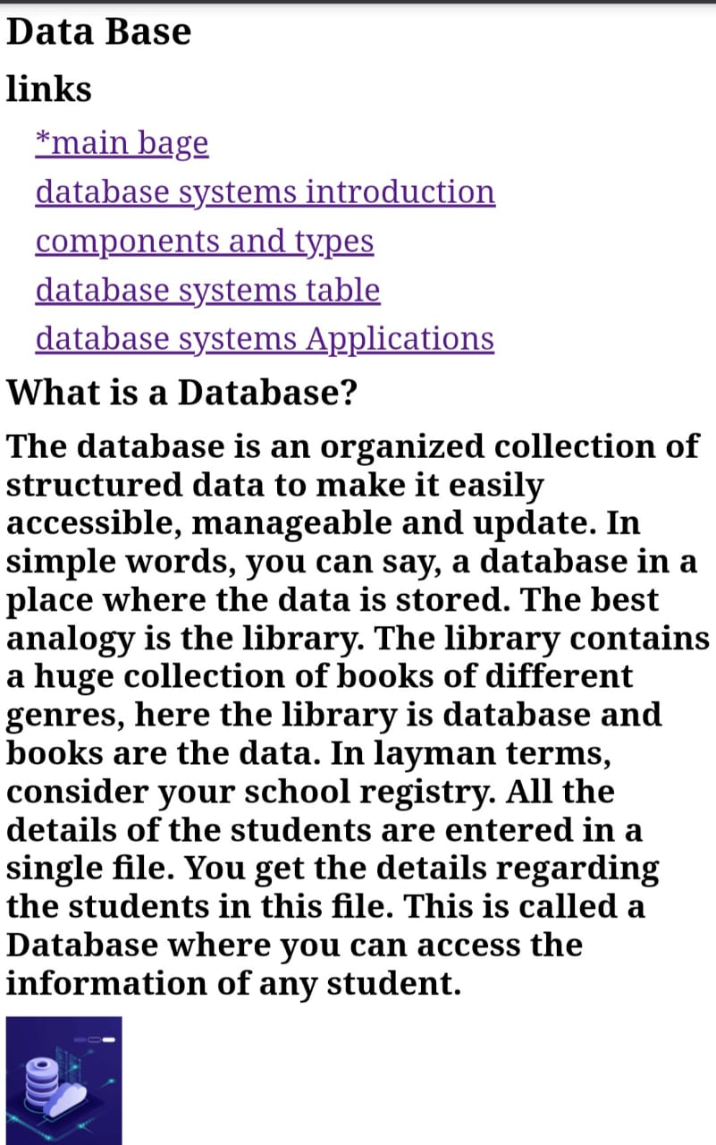**

**site page 2**

**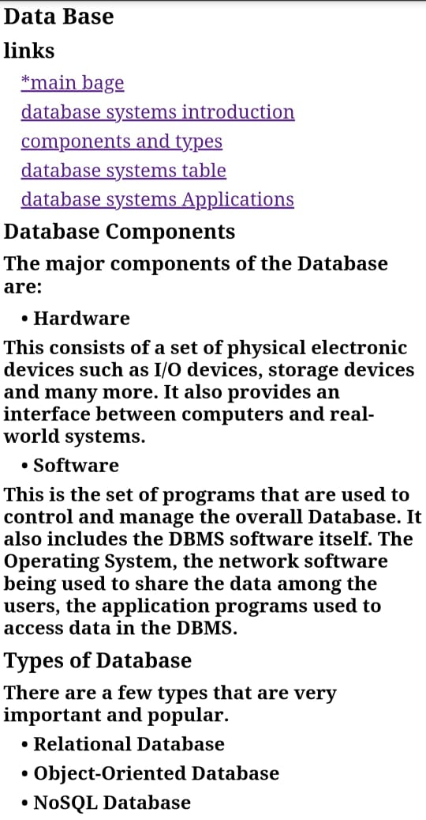**

**Site page 3**

**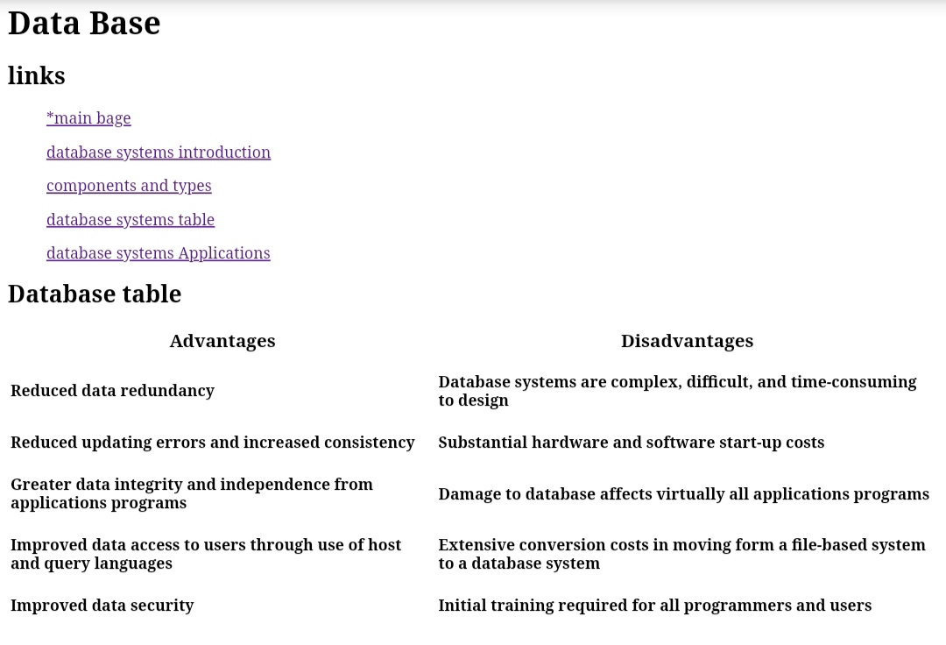**

**Site page 4**

**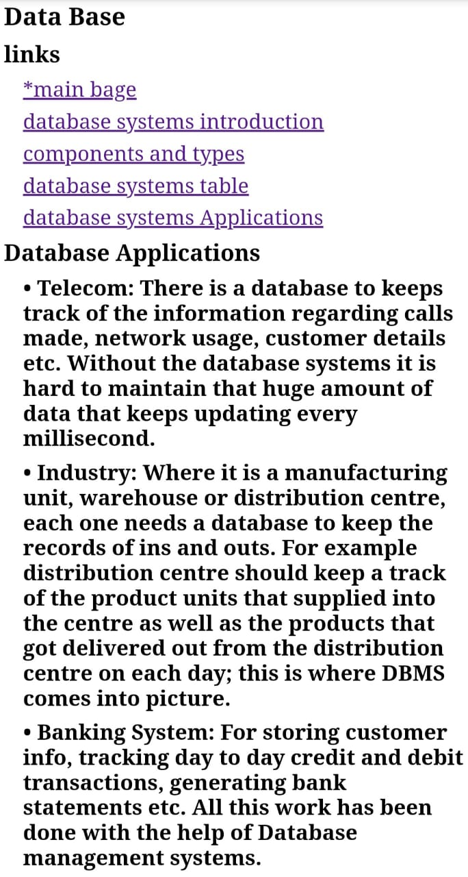**

**Site page 5**

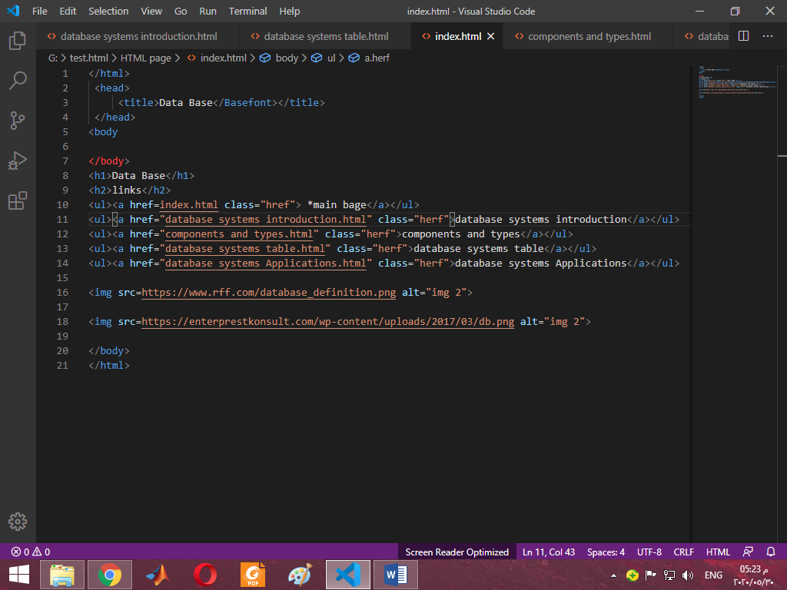

**code page 1**

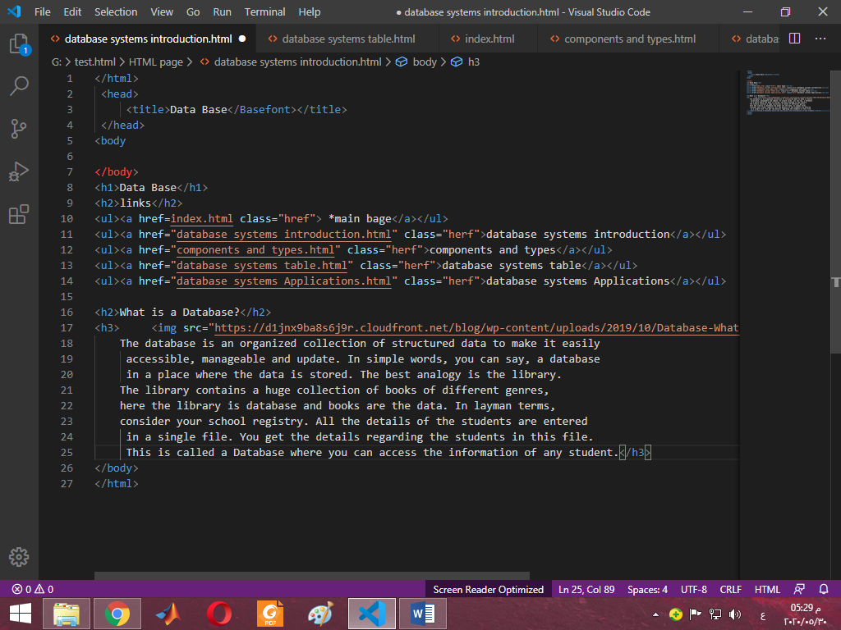

**code page 2**

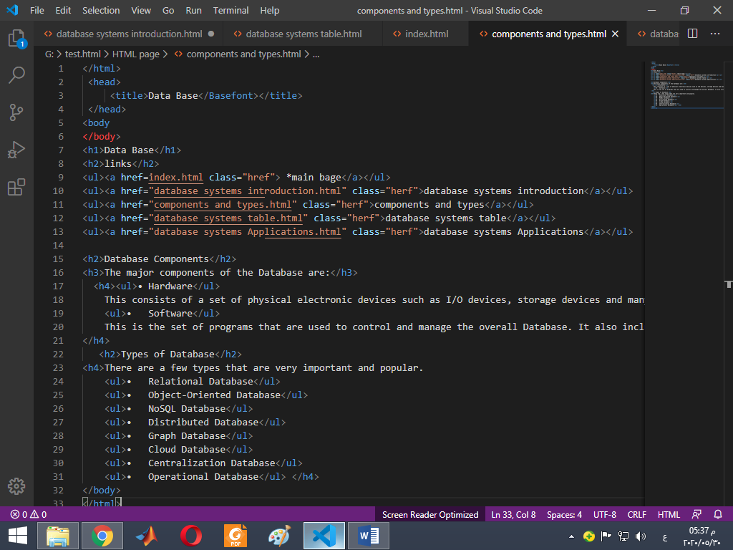

**code page** **3**

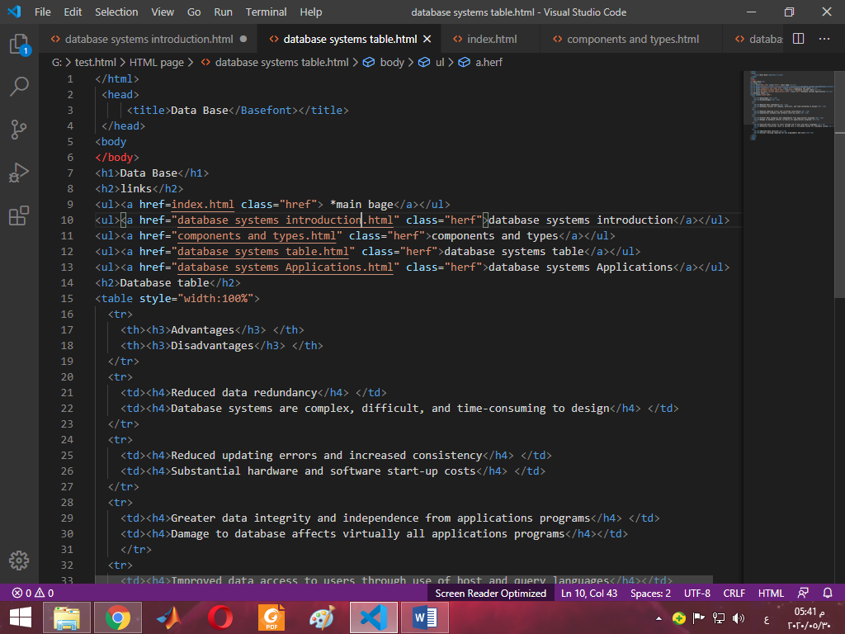

code page 4

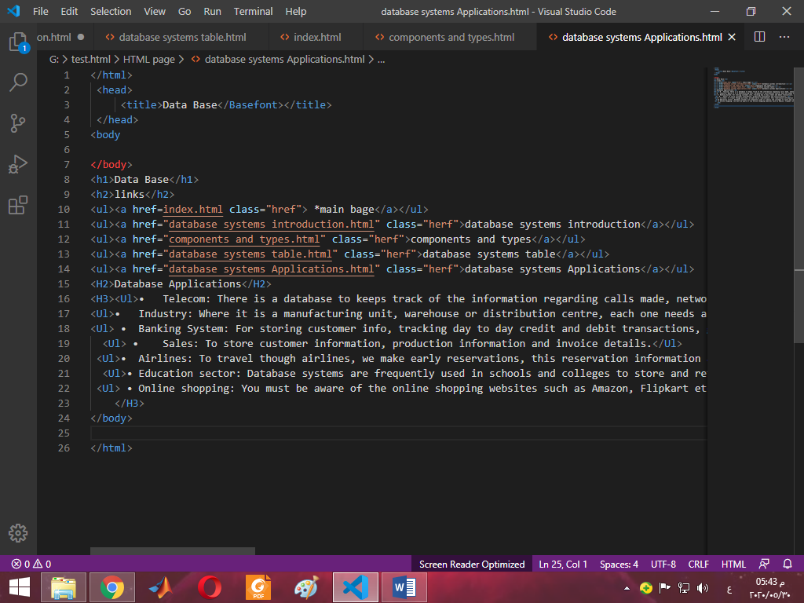

**code page 5**

**REFRENCES:**

-Coronel, C., & Morris, S. (2016). *Database systems: design, implementation, & management*. Cengage Learning.

-DATE, Christopher John. An introduction to database systems. Pearson Education India, 1981.

-KORTH, Henry F.; SILBERSCHATZ, Abraham. Database system concepts 6th Edition. *Chapter*, 2010, 11: 510.‏